**Experiment No. 6**

**Aim: To study various applications of opamp like inverting amplifier, non-inverting amplifier, integrator and differentiator using Proteus.**

**Software required: Proteus 8.**

**Theory:** Pin diagram of IC 741 opamp

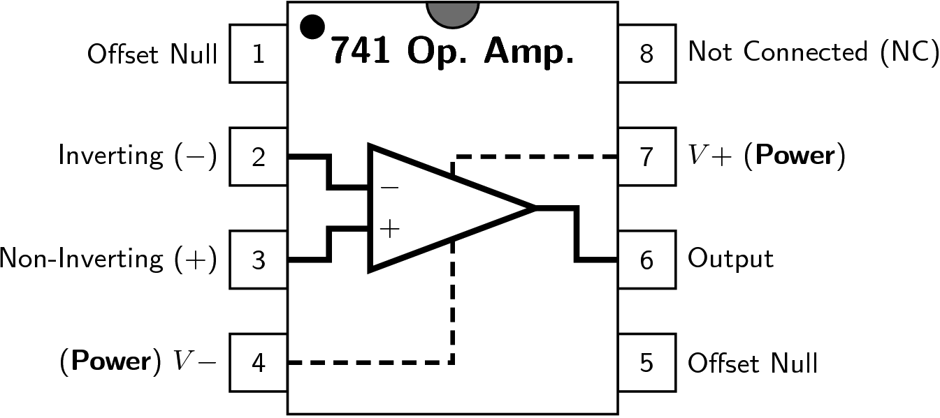

An operational amplifier or op-amp is a linear integrated circuit that has a very high voltage gain, high input impedance and low output impedance. Op-amp is basically a differential amplifier whose basic function is to amplify the difference between two input signals.

Op-amp has five basic terminals, that is, two input terminals, one o/p terminal and two power supply terminals. Pin2 is called the inverting input terminal and it gives opposite polarity at the output if a signal is applied to it. It produces a phase shift of 180o between input and output. Pin3 is called the non-inverting terminal that amplifies the input signal without inversion, i.e., there is no phase shift or i/p is in phase with o/p. The op-amp usually amplifies the difference between the voltages applied to its two input terminals. Two further terminals pins 7 and 4 are provided for the connection of positive and negative power supply voltages respectively. Terminals 1 and 5 are used for dc offset. The pin 8 marked NC indicates ‘No Connection’.

Op-amps have two operating configurations; open loop and closed loop. In open loop configuration, it can operate as a switch but gain is uncontrolled. In closed loop configuration, gain can controlled by feedback resistance Rf and input resistance Rin.

1. **Inverting Amplifier:**

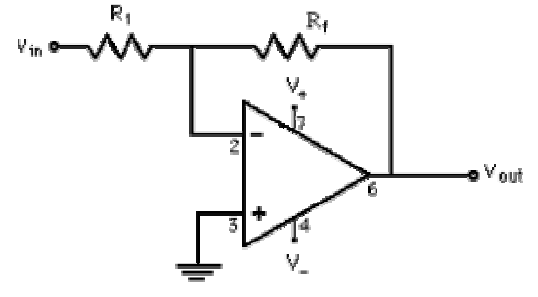

The inverting amplifier is so called because the input is connected to the inverting terminal of the opamp. The name also gives away the form of the output. The output of an inverting amplifier is 180° out of phase of the input, thus the output is inverted. The common inverting amplifier is shown in figure above. The input terminals need to have zero difference between them, so there has to be zero volts at the inverting terminal (-) due to the fact that the non-inverting terminal (+) is grounded. This leads to the node equation of

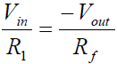

Solving this equation, the transfer function comes out

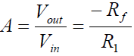

1. **Non-inverting Amplifier:**

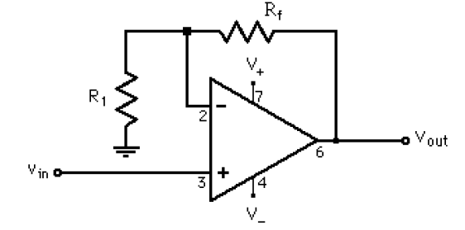

The non-inverting amplifier is so called because the input is connected to the non-inverting terminal of the opamp. By doing the analysis using KCL and KVL, the transfer function, or gain, can be found.

The current rule will force the current to the inverting terminal (-) to be zero. Also the voltage at the inverting terminal (-) needs to match the voltage at the non-inverting terminal (+). This gives the node equations to be

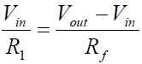

Solving this equation, the transfer function can be found to be

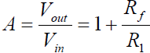

1. **Integrator:**

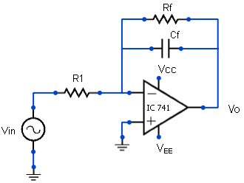

A circuit in which the output voltage is the integral of the input voltage waveform is the ‘integrator’. Output expression of integrator is given by:

Vo = - ( 1 / R1*CF) (Vin dt )

Above expression indicates that the output voltage is directly proportional to the negative integral of the input voltage and inversely proportional to the time constant R1CF. For example, if the input is a sine wave, the output will be a cosine wave; or if the input is a square wave, the output will be a triangular.

1. **Differentiator:**

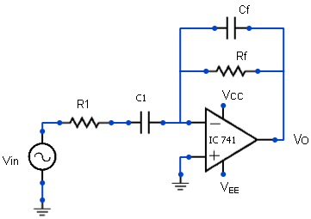

It performs the mathematical operation of differentiation, i.e. the output waveform is the derivative of the input waveform.Output expression of differentiator is given by:

Vo = - Rf C1 ()

Thus, the output Vo is equal to Rf C1 times the negative instantaneous rate of change of the input voltage. Since the differentiator performs the inverse of integrator's function, a cosine wave input will produce a sine wave output, or a triangular input will produce a square wave output.

**Result:**

**Conclusion:**